ACTIVITY 1: GENERATE THE SAME IMAGE USING DIFFERENT TOOLS
(TOOL – CHAT GPT )
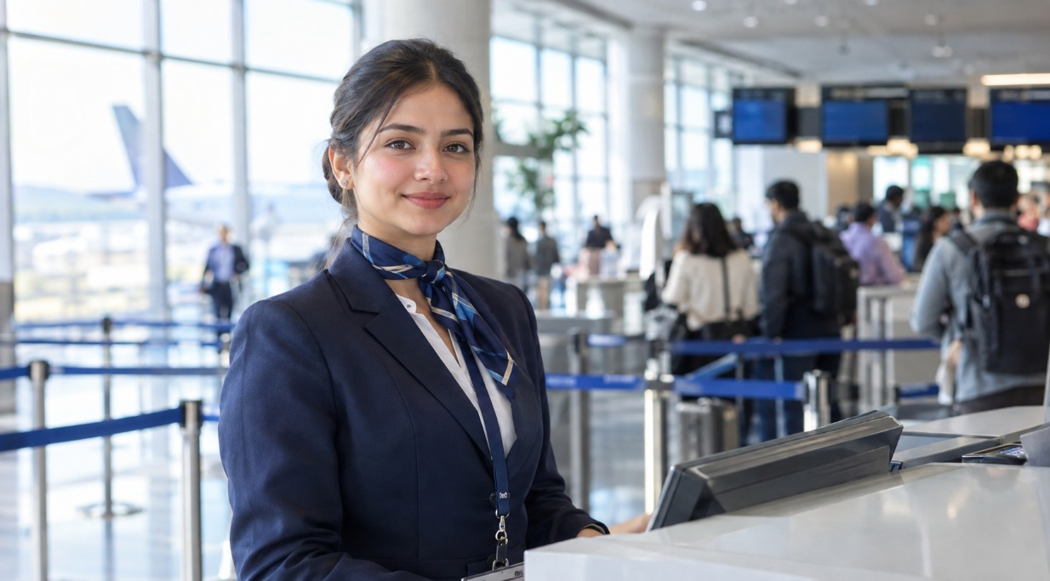
Create a photorealistic image of a female airline customer-service executive standing at a modern international airport check-in counter. She is wearing a professional navy-blue uniform and looking directly at the camera. Soft natural light is entering from camera-left. The airport background is clean and modern, with passengers visible in soft focus. Use realistic skin texture, natural facial features, professional commercial photography, shallow depth of field and a 16:9 aspect ratio. Do not include any airline logo or readable text.

Create a photorealistic image of a female airline customer-service executive standing at a modern international airport check-in counter. She is wearing a professional navy-blue uniform and looking directly at the camera. Soft natural light is entering from camera-left. The airport background is clean and modern, with passengers visible in soft focus. Use realistic skin texture, natural facial features, professional commercial photography, shallow depth of field and a 16:9 aspect ratio. Do not include any airline logo or readable text.
TOOL- 2 ( GEMINI )
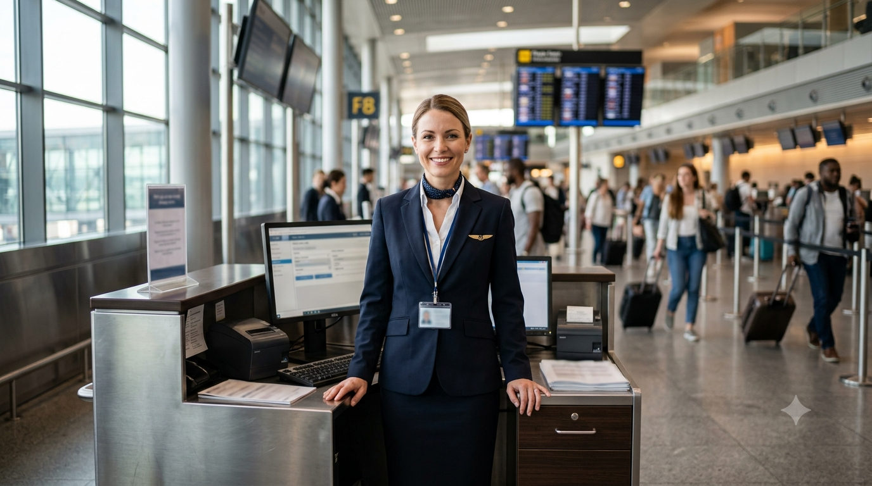

AI Image Generation Comparison
Criteria | ChatGPT | Gemini
Prompt Accuracy | Excellent – follows most requirements | Good – follows main requirements
Face & Skin | 9/10 – natural facial details | 8.5/10 – slightly smooth
Eyes & Hands | 9/10 – accurate and natural | 8/10 – minor AI details
Airport Realism | 9/10 – realistic and professional | 9/10 – highly detailed
Lighting | 9/10 – soft left-side light | 8/10 – lighting less specific
Uniform | 9/10 – professional, no branding | 9/10 – professional but logo visible
Text/Logo Control | 9/10 – minimal unwanted text | 6/10 – visible text/logo
AI Appearance | Low – more natural appearance | Moderate – some artificial details
Overall Score | 9/10 – better prompt compliance | 8.1/10 – strong environment

Analysis Questions
1. Which tool followed the prompt more accurately?
ChatGPT followed the prompt more accurately. It matched the requested uniform, lighting, airport setting, and no-logo requirement.
2. Which image appeared more realistic?
ChatGPT appeared slightly more realistic. The face, skin texture, lighting, and background looked more natural.
3. What differences did you observe in lighting?
ChatGPT had soft, natural light from the camera-left side. Gemini had brighter and more evenly spread lighting.
4. Did either image contain distorted eyes, hands or facial features?
Neither image had major distortions. Gemini showed slightly more artificial details in the hands and facial features.
5. Which image would you use on an airline’s website?
I would choose ChatGPT’s image because it looks professional, natural, and suitable for commercial airline use.
6. What is the “visual accent” of each model?
ChatGPT focuses on a natural and polished appearance. Gemini focuses more on bright lighting, detailed surroundings, and a highly structured airport environment.

Prompt A — Camera-Left
Create a photorealistic image of an airport ground-staff executive standing beside a check-in counter. Soft morning light must enter from camera-left and illuminate the left side of the image. The executive should hold a tablet. Include a modern airport background in soft focus. Professional photography, realistic facial features, 16:9 aspect ratio, no logos and no readable text.

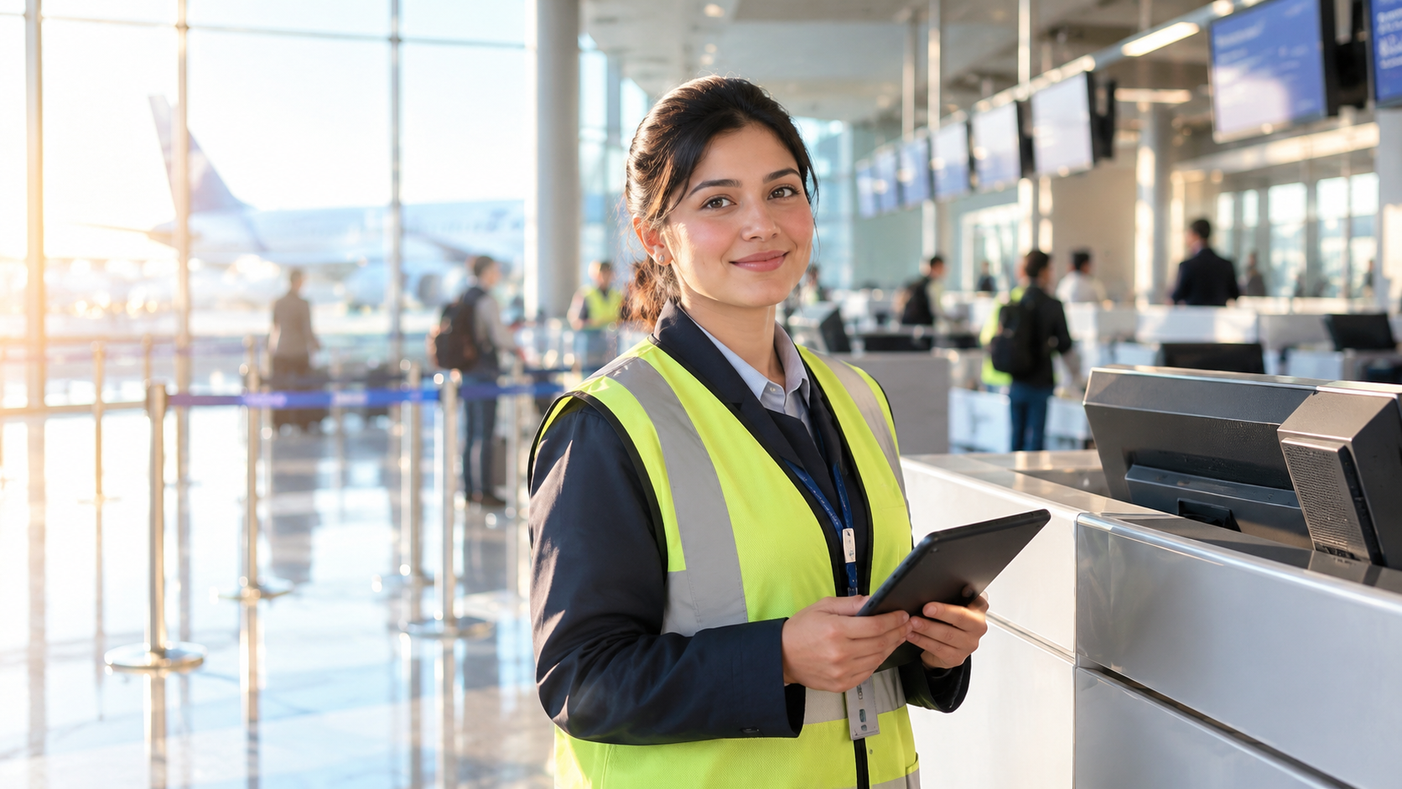
prompt B — Camera-Right

Create a photorealistic image of an airport ground-staff executive standing beside a check-in counter. Soft morning light must enter from camera-right and illuminate the right side of the image. The executive should hold a tablet. Include a modern airport background in soft focus. Professional photography, realistic facial features, 16:9 aspect ratio, no logos and no readable text.



Question | Observation
Did the lighting direction change? | Yes, the light shifted from the left side to the right side.
Was camera-left followed correctly? | Yes, Prompt A showed stronger light from the left.
Was camera-right followed correctly? | Yes, Prompt B showed stronger light from the right.
Did the background remain consistent? | Yes, the airport setting remained similar in both images.
Did the person’s appearance change? | Slightly; the pose and appearance remained mostly consistent.
Which instruction was ignored, if any? | Some background screens contained unclear text-like details.
Record Your Observations

